1. Choose MySQL Command Line Client from Start menu

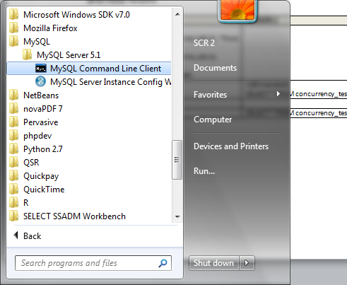

1. Password is BLANK

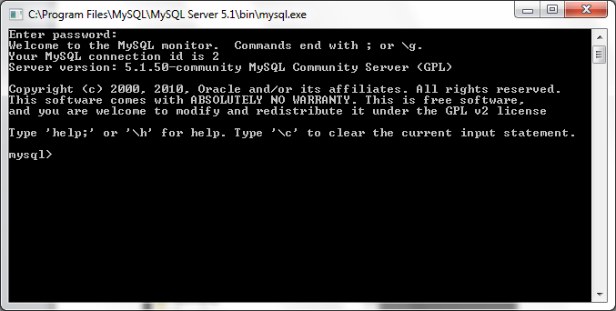

**Basic Commands**

This is a list of basic MySQL.

When you see mysql> it means from a MySQL prompt after logging into MySQL.

**List all databases on the sql server.**

**mysql> show databases;**

**Switch to a database.**

**mysql> use [db name];**

**To see all the tables in the db.**

**mysql> show tables;**

**To see database's field formats.**

**mysql> describe [table name];**

**Show all data in a table.**

**mysql> SELECT * FROM [table name];**

**Returns the columns and column information pertaining to the designated table.**

**mysql> show columns from [table name];**

**How to run SQL text files from within MySQL:**

1. Create a file in Notepad
2. Select the Save As option under file
3. Change the “Save as Type” from ‘txt’ to ‘All Files’
4. Add your file name with a .sql as the extension (**note always add the path to the directory directory where you want this file to be saved!!!**)
5. As below

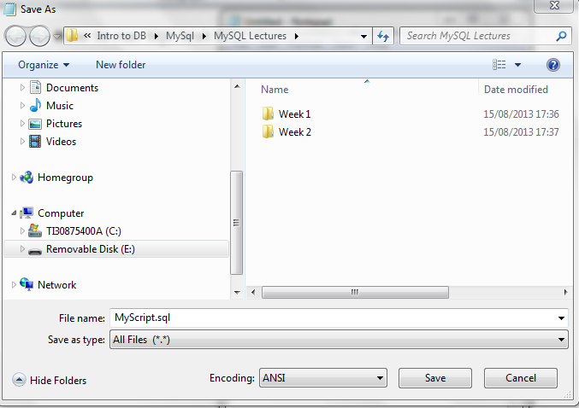

1. The Login to MySql as normal
2. At the MySql prompt type:
   1. The path to where your SQL file is:
      1. **SOURCE** C:/mySql Files/Myscript.sql

**How to output your work to a text file from within MySql:**

1. Command to turn on output = TEE [path and filename]
2. tee h:/MySql/resultsweek1.txt
3. Command to turn off output = NOTEE

**Show certain selected rows with the value "whatever".**

**mysql> SELECT * FROM [table name] WHERE [field name] = "whatever";**

**Show all records containing the name "Bob" AND the phone number '3444444'.**

**mysql> SELECT * FROM [table name] WHERE name = "Bob" AND phone_number = '3444444';**

**Show all records not containing the name "Bob" AND the phone number '3444444' order by the phone_number field.**

**mysql> SELECT * FROM [table name] WHERE name != "Bob" AND phone_number = '3444444' order by phone_number;**

**Show all records starting with the letters 'bob' AND the phone number '3444444'.**

**mysql> SELECT * FROM [table name] WHERE name like "Bob%" AND phone_number = '3444444';**

**Show all records starting with the letters 'bob' AND the phone number '3444444' limit to records 1 through 5.**

**mysql> SELECT * FROM [table name] WHERE name like "Bob%" AND phone_number = '3444444' limit 1,5;**

**Use a regular expression to find records. Use "REGEXP BINARY" to force case-sensitivity. This finds any record beginning with a.**

**mysql> SELECT * FROM [table name] WHERE rec RLIKE "^a";**

**Show unique records.**

**mysql> SELECT DISTINCT [column name] FROM [table name];**

**Show selected records sorted in an ascending (asc) or descending (desc).**

**mysql> SELECT [col1],[col2] FROM [table name] ORDER BY [col2] DESC;**

**Return number of rows.**

**mysql> SELECT COUNT(*) FROM [table name];**

**Sum column.**

**mysql> SELECT SUM(*) FROM [table name];**

**Join tables on common columns.**

**mysql> select lookup.illustrationid, lookup.personid,person.birthday from lookup left join person on lookup.personid=person.personid=statement to join birthday in person table with primary illustration id;**

**To update info already in a table.**

**mysql> UPDATE [table name] SET Select_priv = 'Y',Insert_priv = 'Y',Update_priv = 'Y' where [field name] = 'user';**

**Delete a row(s) from a table.**

**mysql> DELETE from [table name] where [field name] = 'whatever';**

**Update database permissions/privilages.**

**mysql> flush privileges;**

**Create a database on the sql server.**

**mysql> create database [databasename];**

**To delete a db.**

**mysql> drop database [database name];**

**Delete a column.**

**mysql> alter table [table name] drop column [column name];**

**Add a new column to db.**

**mysql> alter table [table name] add column [new column name] varchar (20);**

**Change column name.**

**mysql> alter table [table name] change [old column name] [new column name] varchar (50);**

**Make a unique column so you get no dupes.**

**mysql> alter table [table name] add unique ([column name]);**

**Make a column bigger.**

**mysql> alter table [table name] modify [column name] VARCHAR(3);**

**Delete unique from table.**

**mysql> alter table [table name] drop index [colmn name];**

**Load a CSV file into a table.**

**mysql> LOAD DATA INFILE '/tmp/filename.csv' replace INTO TABLE [table name] FIELDS TERMINATED BY ',' LINES TERMINATED BY '\n' (field1,field2,field3);**

**Create Table Example 1.**

**mysql> CREATE TABLE [table name] (firstname VARCHAR(20), middleinitial VARCHAR(3), lastname VARCHAR(35),suffix VARCHAR(3),officeid VARCHAR(10),userid VARCHAR(15),username VARCHAR(8),email VARCHAR(35),phone VARCHAR(25), groups VARCHAR(15),datestamp DATE,timestamp time,pgpemail VARCHAR(255));**

**Create Table Example 2.**

**mysql> create table [table name] (personid int(50) not null auto_increment primary key,firstname varchar(35),middlename varchar(50),lastnamevarchar(50) default 'bato');**